Frank Lloyd wright Apprentice Manifesto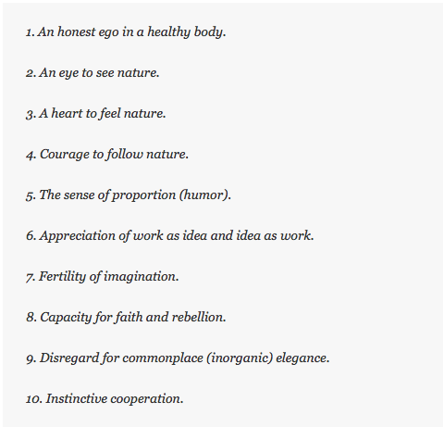http://www.colleendavidson.com/blog/wp-content/uploads/2011/04/MANIFESTO.png